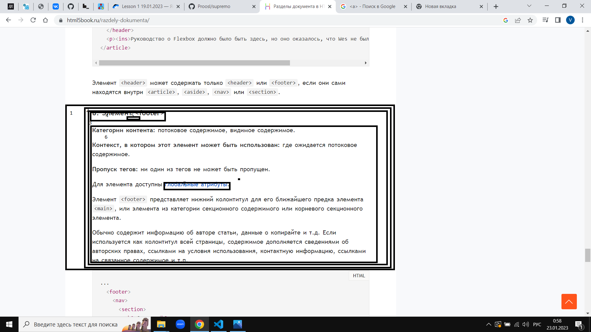

1. Section
2. Div class = container
3. Div class = wrapper
4. Div
5. H2
6. P
7. Div + p
8. A href